Selected Excerpts From NNSA’s
FY 2012 Performance Evaluation Reports

The National Nuclear Security Administration (NNSA) has recently released fiscal year 2012 Performance Evaluation Reports on its contractors at its eight nuclear weapons sites, following Nuclear Watch New Mexico’s successful lawsuit for its FY 2011 Reports. These assessments are the scorecards for Performance Evaluation Plans negotiated between the government and its nuclear weapons contractors, which awards the contractors hundreds of millions of taxpayers’ dollars. Public access to these reports is of increasing importance as federal oversight is being continuously diminished. The trend of soaring contractor profits coupled with decreasing accountability should be reversed, especially given sequester budget cuts that will further handicap federal oversight.

Nuclear Watch New Mexico offers these excerpts as a public service in the hopes of promoting greater transparency within the U.S. nuclear weapons complex and greater NNSA contractor accountability. We have focused on nuclear weapons programs, but nothing in these Performance Evaluation Reports is classified. These excerpts are verbatim (with page numbers added), but any comments or additions by NukeWatch are in italics. We have tried to be accurate while compiling these excerpts, but any references to or quotes from them should be checked against the originals. Additionally, considerable original formatting has been lost while compiling these excerpts.

Please go to http://www.nukewatch.org/PERs-PEPs.html for our press release on NNSA’s FY 2012 Performance Evaluation Reports, our Analysis and Conclusions, past and present Performance Evaluation Plans Reports, and some relevant Congressional and Government Accountability Office documents.

NNSA FY 2012 Performance Evaluation Report Excerpts Page
The Kansas City Plant 2
Lawrence Livermore National Laboratory 4
Los Alamos National Laboratory 7
Nevada National Security Site 10
Pantex Plant 14
Sandia National Laboratories 18
Savannah River Site not available, under request
Y-12 25
Performance Evaluation Report (PER)
Kansas City Plant
October 1, 2011 through September 30, 2012
Honeywell Federal Manufacturing & Technologies, LLC

Page 4: Noteworthy accomplishments for FY 2012 include:
• Completed all 37 Directed Stockpile Work (DSW) milestones in the KCP DSW Execution Plan.
• Provided FY 2012 B61 Option 3B development hardware requirements; updated manufacturing readiness level assessments and maturation forecasts; and supported NNSA Federal Program Management and Design Laboratories on the issuance of a new Work Breakdown Structure.
• Contributed to closure of W76-1 Life Extension Program (LEP) Code Blue conditions for the MC4713 Launch Accelerometer and the MC4682 Dual Capacitor.
• Delivered the first shipment of B83 ALT 353 development hardware ahead of schedule.
• Developed production strategies for system and component level conceptual design review supporting W88 ALT 370 Integrated Phase Gate processes.
• Delivered all Base Spares and ERS-PCD equipment requirements including 30 each of UP1643 Power Modules, 30 days ahead of the First Production Unit schedule.
• Developed a reduced production strategy to accommodate delayed MC4682 Dual Capacitor deliverables to the KCP, avoiding discontinuity in production processing, minimizing risks and reducing costs associated with a complete production stop/restart.
• Supported the B61 LEP revised Option 3B, W88 technology maturation and Gas Transfer System (GTS) weld development, forging development and legacy tester development through Readiness Campaigns…

Page 5: Significant Issue
In FY 2012, Honeywell FM&T failed to provide an acceptable level of fidelity in a key business system, Enterprise Resource Planning (ERP), to estimate development costs. Cost estimating process and system validation gaps resulted in a significant cost estimation error in the B61 Life Extension Program Weapon Design Cost Report (WDCR) submitted to Headquarters during the first quarter of FY 2012. Although the error was self-identified and a corrective action has now been implemented, the magnitude and potential impact of the error was of significant concern. In addition, FM&T delayed implementing the Nuclear Plant Program (NPP) baseline management approach specifically related to Earned Value Management System (EVMS) performance measurements and resource loaded scheduling for the B61-LE

Page 6: The FM&T Quality Director visited the United Kingdom to share best practices and lessons learned with quality and production operations staff.
Page 7: Tenant Improvement (TI) costs increased significantly ($20 million) in FY12 from original projections causing KCRIMS to baseline Tenant Improvements at a higher amount than was planned. TI was procured by GSA through the lease and FM&T had a limited role, primarily defining scope for TI. Designs and estimates by the developer were one year late, which reduced the opportunity to take corrective actions. FM&T implemented a number of cost savings opportunities to minimize the increase after it became visible. FM&T was able to accommodate the increase within the original budget request, due to savings realized at the existing KCP. Factors contributing to the TI increase were largely outside of FM&T’s control. The overall increase will likely be significantly less after TI costs are reconciled by GSA and after the 50 - 50% core/s hell savings are accounted for.
Page 7: The KCRIMS Occupancy Project has experienced problems with the accuracy of the government cost estimates. There have been cases where the estimates were either incomplete or inaccurate.

Page 8: FM&T made significant progress in supporting efforts for rapid sale/reuse of the existing Kansas City Plant. A developer has been selected as the preferred planning partner to develop a strategy for transfer of the KCP Real Property to a non-federal owner. The Missouri Department of Natural Resources (MDNR) and the Environmental Protection Agency (EPA) approved modifications to the Resource Conservation and Recovery Act (RCRA) permit. Actions regarding National Environmental Policy Act (NEPA) are in progress to support disposition.

Att 1, Page 6: All milestones have been met. FM&T was able to accomplish this despite the work strike. Workforce transformation progress continues to be made to reduce potential layoffs. Fifty four percent of the employees in a potential layoff pool have been addressed. All action items from peer review reports were fully addressed. KCFO validated KCRIMS labor cost savings plans and FM&T is significantly ahead of schedule with $69M of $100M goal already reached. FYNSP submission fully supported the KCRIMS funding requirements.

Att. 1 Page 7: Honeywell FM&T was able to work with the development community to get them to provide reuse and redevelopment proposals. This will greatly minimize future cost to the Bannister Federal Complex, be perceived very positively by the public, and be a positive impact on the City. A preferred planning partner was selected in August 2012.

Att. 1 Page 14: Ensure 76 LEP production for subassemblies (except the MC4700 AF&F) remains on schedule as identified in the W76-01 PCD. Ensure MC4700 AF&Fs are available for Pantex assembly and W76-01/Mk4A Reentry Bodies are available for delivery to U.S. Navy in accordance with FPM recovery schedules.

Att. 1 Page 14: Complete FY12 B61 Phase 6.3 Development Engineering activities that enable a 2017 FPU… Conduct Phase 6.X activities for the W78 LEP.

- End of FY 2012 KCP Performance Evaluation Report Excerpts -

Fiscal Year 2012 Performance Evaluation Report
Lawrence Livermore National Laboratory
Prepared by: Livermore Site Office
National Nuclear Security Administration
November 30, 2012
Addendum 1 January 30, 2013

Page 1: Addendum 1: It is noted that subsequent to the issuance of the PER that the NNSA FDO exercised her authority on December 5, 2012, making an adjustment to the recommended incentive fee, which resulted in the Contractor earning the award term. The Fee Determining Officer was Neile Miller, then Deputy and now Acting NNSA Administrator.

Page 2: The Contractor earned 78% of its available incentive fee and did not meet the incentive fee gateway of 80% to be eligible to earn the award term. Although the Contractor successfully completed all five ATI targets, it failed to qualify for an additional year of term.

Page 3: All programs objectives were performed at the excellent level with the exception of ICF, which was rated very good by LSO and excellent by the Contractor. Although the Contractor met or exceeded nearly all of the performance targets, evaluation criteria, and milestones associated with the program objectives, there were key milestones on the NIC Program that were not completed as well as other NIC performance issues t hat resulted in the programs rating being downgraded from excellent to very good. The NIC was one of the Contractor’s major programs in FY 2012. Since nearly all of the programs performance measures were rated excellent, the earned essential fee of 90% is at the top of the very good range (76% to 90%). The Contractor successfully completed 8 out of 9 stretch targets earning 89% of its available stretch incentive fee and 90% of its total incentive fee available for programs.

Page 4: Studied future LEP concepts, including a significant effort dedicated to the W78/W88 120- day study; and supported future LEP options with a major safety experiment at LLNL’s Superblock and excellent progress on maturation of relevant technologies… Conducted three integrated weapon experiments (hydrotests) at CFF, including a number of technical “firsts” associated with LLNL’s collaborative all-optical subscale shot with AWE, which gathered data to improve models and design codes.

Page 7: NNSA leadership was sensitive to the Contractor’s failure to partner in reaching enterprise solutions to significant management challenges. Moreover, the lack of engagement by parent companies, e.g. Board of Governors, to ensure that NNSA leadership issues and concerns were addressed in resolving these significant management challenges was also an issue. Lastly, there was inconsistent implementation of the Contractor Assurance System across all functional areas and improvements needed to the institutional QA pro gram.

Page 8: Eliminated all NIF special allocations, e.g. SCAP rates, and submitted a revised disclosure statement that corrected other potential Cost Accounting Standards (CAS) non-compliances.

Page 10: Assessed and innovated options for the stockpile, including for the W78/W88 120-day study and the Air Force-led Long-Range Stand-Off (LRSO) study. As a question, could the LRSO possibly be a new air-launched cruise missile (ACLM), while at the same time according to the Pantex Performance Evaluation Report all ACLM W80-0 warheads have been dismantled?

Page 11: Executed three integrated weapon experiments (hydrotests) at CFF. Two were hosted shots for LANL and SNL to address questions related to two stockpile systems. LLNL's shot was a major experiment in support of future certification strategies that are part of an ongoing collaboration between LLNL, LANL, and AWE, and demonstrated number of technical "firsts" as the first scaled all-optical shot at CFF. LLNL used the data from this shot to improve the models and design codes for a stockpile system.

Page 11: It is noted that the Contractor failed to achieve its stretch target (3. 2.1) under ICF as well as the NNSA multi-site target (2.1) on achieving ignition, resulting in an additional reduction in fee of over $1.3 million ($429,783 stretch + $892,627 multi-site) above and beyond the essential fee.

Page 11: While the Contractor has met the difficult challenge of successfully managing and completing the vast majority of NIC milestones, the program has ended with some key deliverables not being met. Specifically, two very important milestones, alpha heating and ignition were not accomplished. Although these milestones represent significant scientific breakthroughs and achieving them was always understood to be a great challenge, their importance to the future success of the NIC program and stockpile stewardship cannot be overstated. Additionally, the rate that experiments were accomplished on NIF remains below design expectations as the Contractor’s priority has been on the effort to achieve ignition in lieu of conducting stockpile stewardship experiments. The Contractor should develop an alternative research plan to move forward towards ignition, building on the research already completed and working in consonance with NNSA HQ and the ICF community.

Page 13: It is noted that there was an issue regarding the execution of a project for the NNSA Office of Emergency Response. The Contractor has acknowledge d that funding for the development of a neutron multiplicity detector for NA-42/82 was used to perform work not within the project scope, which has caused delays in the projected completion date and aspects of the work to be reallocated to other laboratories. The Contractor is in the process of reimbursing the program out of its management fee and resolving the issues.

Page 15: It also entered into 4 new CRADAs, issued 77 new U. S. patents, filed 163 new records of invention, and earned $9.7 million in licensing royalty income.

Page 19: There were opportunities for improvement in the quality, timeliness, and planning (e.g., failure to submit the supporting documentation for the 14 key criteria for the minimum staffing amendments; failure to follow SQA requirements for modeling software for calculations; lack of communication between program, facility, and safety basis staff resulting in confusing or incorrect submittals) regarding the safety basis documents submitted to LSO.

Page 20: CAT III Transition The Contractor completed post de-inventory security program planning and was ready to implement CAT III security operations before October 1, 2012. On October 2, 2012, LSO approved LLNL’s Site Security Plan and downgraded its facility clearance authorization from CAT I to CAT III SNM.
• LLNL’s new security posture will save NNSA at least $40 million per year;
• LLNL de-inventory of CAT I/II SNM was completed ahead of schedule. Security Organization support of de-inventory was instrument al in achieving this objective.

Page 24: A critical part of successful Institutional Management is assuring performance and long term viability at the National Laboratory level while demonstrating the necessary leadership to assure the overall success of the NNSA enterprise mission. This can only be achieved through an effective and active partnership with NNSA. In the past year there have been several serious management challenges including the pursuit of ignition at NIF, the transition to a compliant overhead rate structure, and planning for the future operations of the NIF facility. In addressing these challenges, LLNS management has not consistently acted in partnership with NNSA in seeking solutions. There have been numerous examples where LLNS management actions have made these problems more difficult to solve. There has also been a notable unwillingness of the parent companies to become engaged in resolving the se issues. Moreover, the Contractor did not work effectively across its internal stovepipes of ICF, Science, and Weapons to communicate and resolve the discrepancies of the ICF codes not predicting reality in the implosions. These discrepancies were left unresolved well after they became apparent to the Contractor, which was a failure of its institutional leadership. These management failures have had significant consequences for the Laboratory as well as for the NNSA organization as a whole. As a result, a significant reduction was made to the overall rating for this performance objective.

Page 30: See excellent and very good ratings for NIF, contrary to narrative. NNSA LLNS
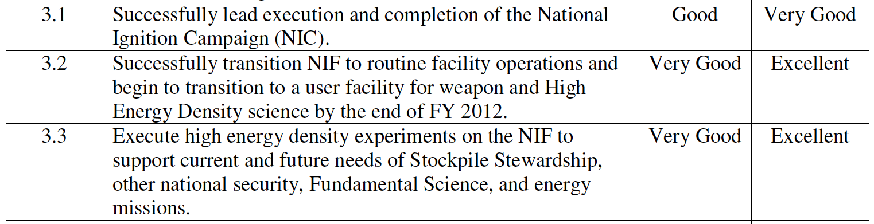
Page 34: Exceed expectations in execution of the National Ignition Campaign by completing any of the following three t asks: 1. Perform two ignition shots with Gain >1. 2. Complete the NIC level-2 milestone “Demonstrate Gain = 1 in a DT implosion experiment” more than 30 days ahead of schedule. 3. Complete the NIC level-2 milestone “Demonstrate limited alpha heating in a DT implosion experiment” more than 30 days ahead of schedule. Marked with “Fail”

- End of FY 2012 LLNL Performance Evaluation Report Excerpts –

FY 2012 PERFORMANCE EVALUATION REPORT FOR THE
LOS ALAMOS NATIONAL SECURITY, LLC’S
MANAGEMENT AND OPERATION OF THE
LOS ALAMOS NATIONAL LABORATORY
CONTRACT NO. DE-AC52-06NA25396
PERFORMANCE PERIOD
OCTOBER 1, 2011 THROUGH SEPTEMBER 30, 2012

Page 2: The contract with LANS, awarded in December 2 005, reflects a change in the National Nuclear Security Administration’s (NNSA) philosophy for performance based contracting. Some of the major philosophy changes reflected are:
1. NNSA specifies “what“ it wants rather than dictating to the contractor “how” to get it done.
2. There is an increased reliance on contractor assurance of it s systems and operations, which includes a rigorous self-assessment process and significant involvement and oversight from LANS parent companies.
3. The liability for performance is shifted from the government to the contractor.

Page 2: Under this contract, LANS also receives a fixed fee of 2.5% of the estimated cost of NNSA’s total estimated budget for reimbursable projects. For FY 2012 the fixed fee amount for WFO is $7,994,910. No incentive fee is paid for Work for Others (WFO) projects; however, LANS management of WFO as a portfolio and its facility and operations implications are addressed subjectively

Page 3: LANS executed over $2.1B in programmatic work authority absorbing over $380M in reduced programmatic budget authority and managing continuing resolutions… LANL effectively responded to a decision by NNSA to defer the Chemistry and Metallurgy Research Replacement Project Nuclear Facility through development of a revised Plutonium Strategy, including development and execution of the Plutonium Sustainment and Plutonium Research and Science Strategy Implementation Plans.

Page 3: Despite significant progress and achievements on many fronts, LANL experienced two significant operational disruptions during FY2012. The first involved the declaration of an Operational Emergency resulting from accidental spread of Tc-99 Radioactive Materials from the Los Alamos Neutron Science Experimental Facility (LANSCE) in August. The second involved the inability to complete construction of the Nuclear Materials Safeguards and Security, Phase II line item construction project.

Page 3: FY2012 Performance Evaluation Plan wise, LANS has earned the fixed fee of $19,954,675 as specified in Section B-2 (C) (4) of the contract. The Fee Determining Official (FDO) has awarded $34,224,479 of performance fee, which is 74% of the LANS FY 2012 incentive fee pool of $46,560, 909. As a direct result of the operational performance score, LANS did not meet performance requirements and hence, did not achieve Award Term gateways.

Page 3: LANS completed all onsite deliverables required in support of the Multi-Site commitments and despite the NNSA Complex not achieving ignition at National Ignition Facility, LANL did deliver neutron imaging and Gamma reaction history diagnostics in support of this effort.

Page 5: Award Term: Not awarded. NOTE: The Fee Determining Official (FDO) restored Award Term, as reflected in the FDO letter issued December 7, 2012.

Page 8: Fee awards. LANS did not do so well.
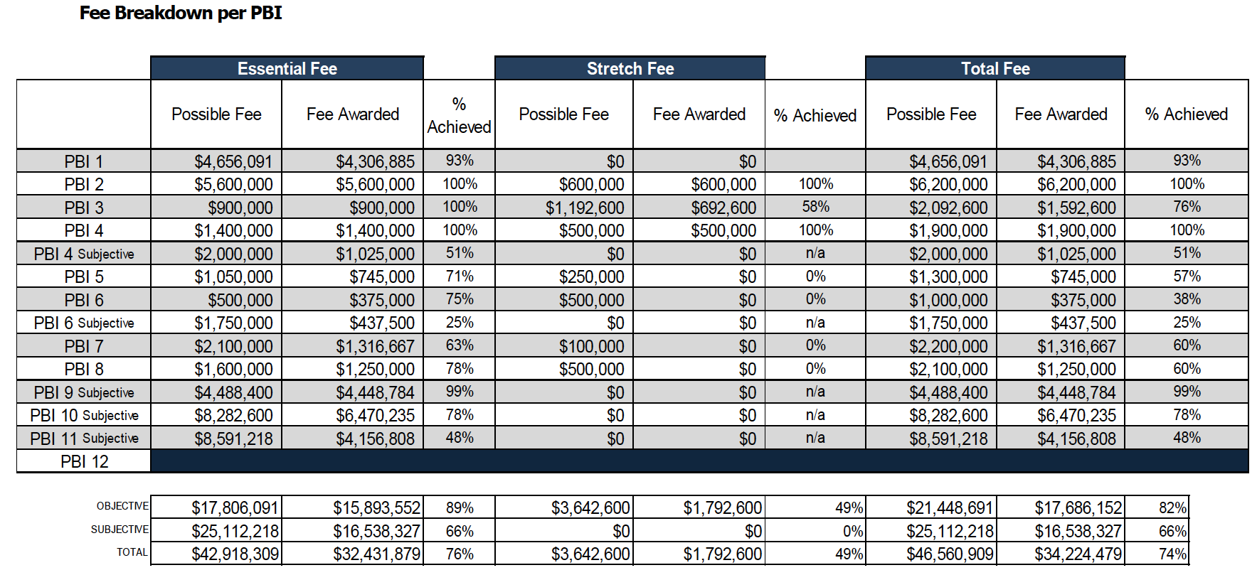

Page 11: 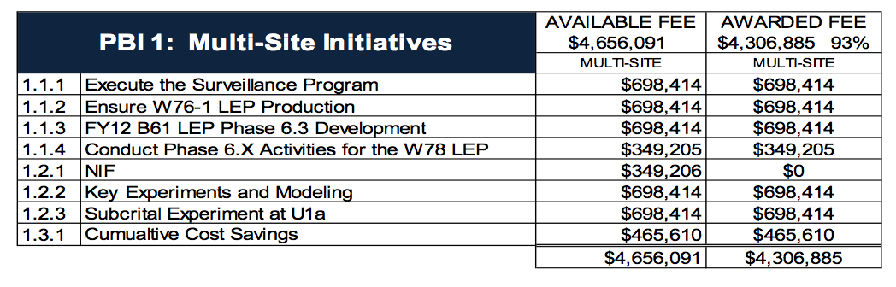
Page 11: Expectation Statement: Develop the B61-12 Option 3B program plan, including schedule and validated costs, to enable a 2019 FPU. Completion Assessment: LANS has submitted completion evidence denoting award of full fee. NNSA review has validated that this is appropriate.

Page 13: LANS will demonstrate Weapons Program capability sustainment and transition in the following projects: • Sample Management Relocation from CMR to PF-4

Page 14: note high stretch fee for MOX and no stretch fee for “other nonproliferation objectives”

Page 18: environmental planning is “good” and Area G BIO [Basis of Interim Operations] “satisfactory”

Page 21: site-wide project management is “satisfactory”

Page 22: Nuclear Safety $0 award
Expectation Statement: Address longstanding safety issues and demonstrate improvement by fully establishing the annual Safety Bases update process. Active management of annual DSA update submittals and implementation of the approved updates will be used to demonstrate that the annual update process required by 10 CFR 830, Nuclear Safety Management, is implemented at LANL. Completion Assessment: LANS has submitted completion evidence denoting award of full fee, however NNSA review has resulted in a differing evaluation of performance.

Page 23 ($0 award Fire Protection) Expectation Statement: Continuation of the on-going program established in FY 2008 that identifies, prioritizes, coordinates funding, and oversees the successful resolution of long-standing fire protection deficiencies within legacy facilities at LANL. The list of legacy facility deficiencies is maintained up-to-date, reflects accurate information, and is reviewed semi-annually. Completion Assessment: LANS has submitted completion evidence denoting award of partial fee, however NNSA review has resulted in a differing evaluation of performance.

Page 25: $0 award for NMMSUP

Page 28: Successful completion of significant UK mission deliverables

Page 29: Functionality and operations of Emergency Operations Center remains less than adequate

Page 31: FY 2007-09 Statements of Cost Incurred and Claimed (SCICs) remain unresolved and in a "Qualified" status; FY 2010 & 2011 SCICs still under review

Page 32: Poor management of construction projects, inadequate cost tracking and management, inadequate management of subcontractors, and inconsistent delivery of projects on time and within budget…. biz and inst. Management just “satisfactory.”

Page 35: Effective use of the 50 year Environmental Stewardship and Action Plan as the primary LANL environmental management tool.

Page 36: NMED and EPA have significant issues with operations at the TA-3 Power Plant.

Page 38: Line Items Projects: LANS failed to complete a critical security project, NMSSUP, on schedule within budget. The inability to complete NMSSUP puts NNSA in a higher cost profile for an undetermined period of time. Performance on this project is unacceptable. Additionally, other infrastructure projects were not well managed: LANS failed to respond to the DNFSB comments on the RLWTF and the TWF in a timely manner which puts the CD-2 approval at risk (for TWF)… Project Management Framework: LANS has consistently had difficulties in defining financial and earned value data to ensure “real time” project status and concerns remain with accrual process deficiencies. Integration of key functions has also resulted in delays and missed opportunities to progress the projects. Finally, LANS has struggled with controlling requirements and having a disciplined structure to manage projects - End of FY 2012 LANL Performance Evaluation Report Excerpts -
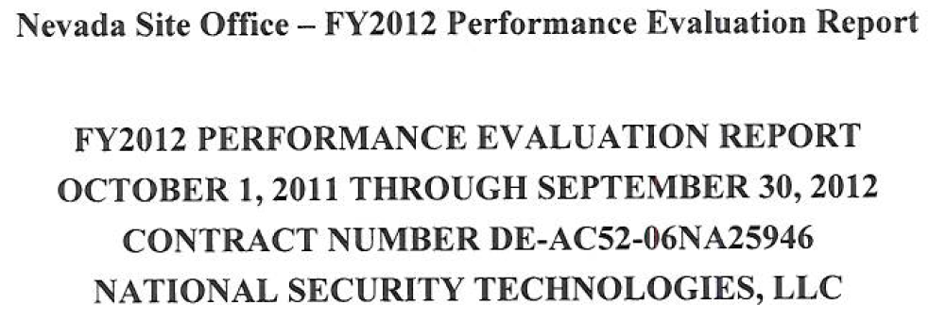
Note: All excerpts for the Nevada Performance Evaluation Report are “grab and capture” pictures rather than text.

Page 1:
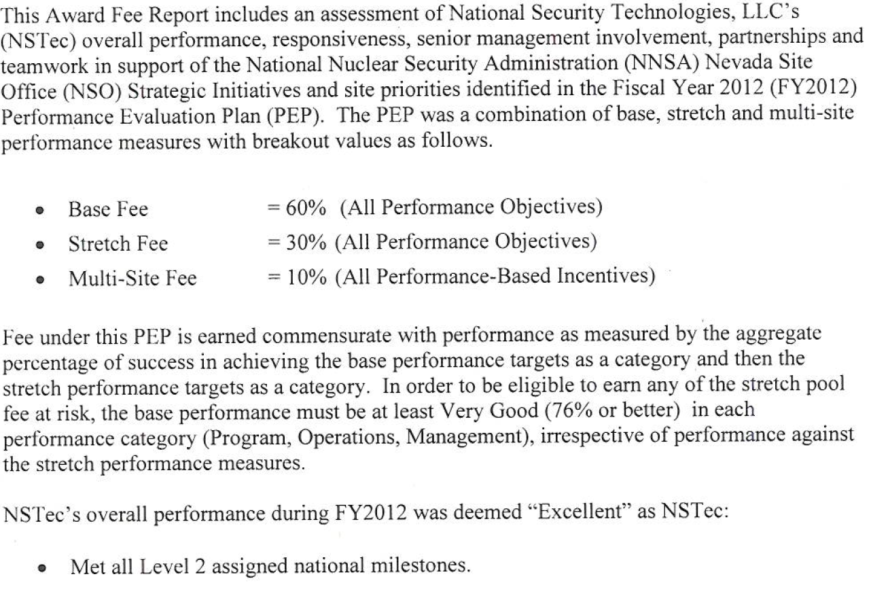
Page 3:
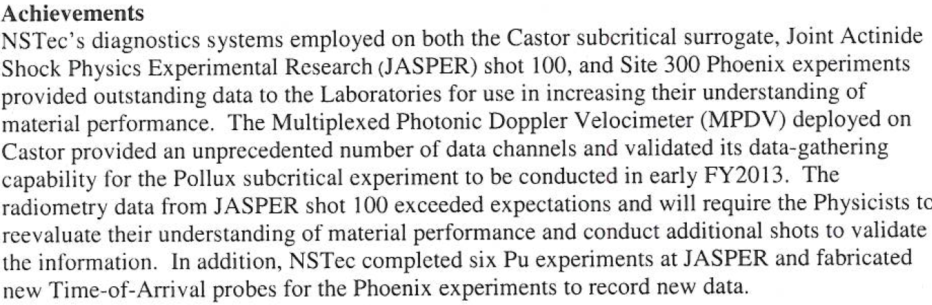

Page 4:
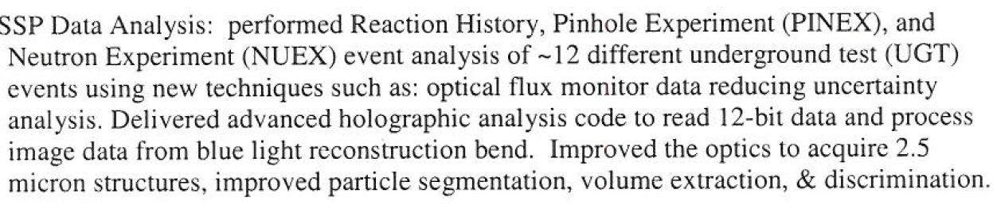

Page 11:
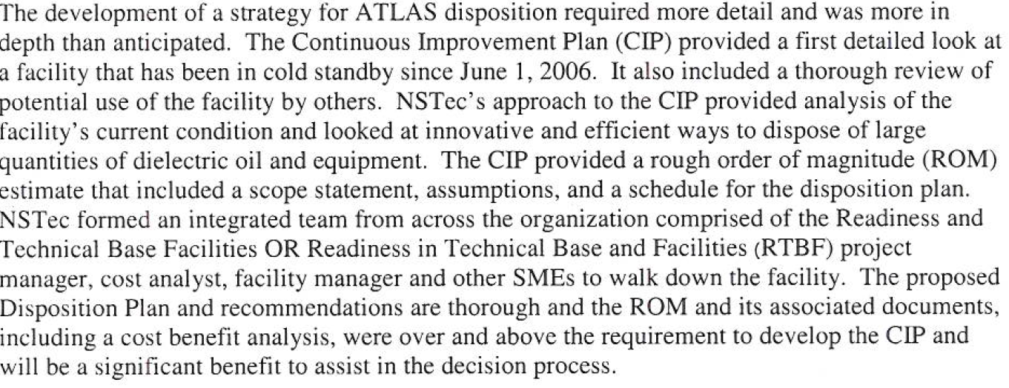
ATLAS (the Augmented Test Logistics Assembly System) was originally built at the Los Alamos National Laboratory (LANL) and transferred to the Nevada Test Site (now the Nevada National Security Site). The Department of Energy claimed that ATLAS was absolutely critical to nuclear weapons stewardship in its 1996 Stockpile Stewardship and Management Programmatic Environmental Impact Statement. It is now being junked at an undisclosed cost to the taxpayer.

Page 12:
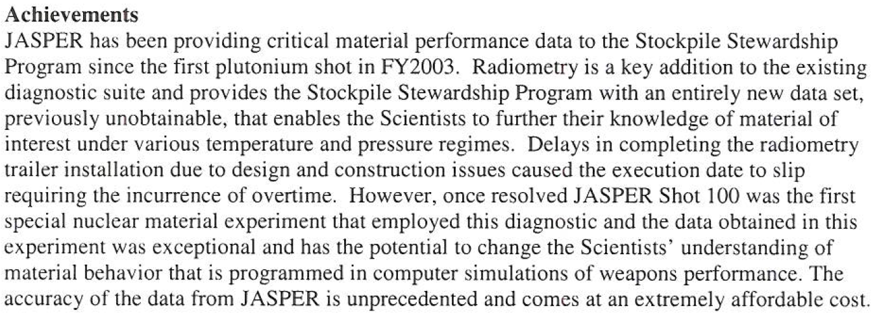JASPER is the Joint Actinide Shock Physics Experimental Research Facility, a two-stage high-energy shock gun specifically designed to conduct research using plutonium and surrogate materials in nuclear weapons-related tests. Data from these experiments are used to determine material equations of state and to validate computer models of material response for weapons applications. JASPER experiments support the Stockpile Stewardship Program and complement subcritical experiments conducted in NNSS Area 1. (Paraphrased from Wikipedia.)

Page 20: To be clear, the Nevada National Security Site’s number one priority is sub-critical nuclear weapons tests.
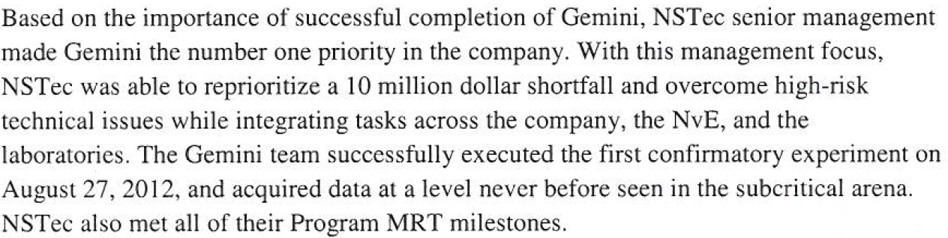

Page 20:
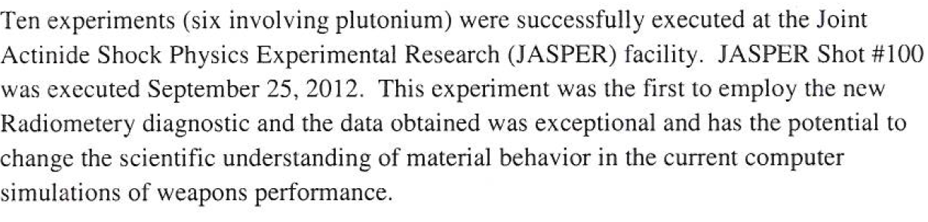
Page 23:
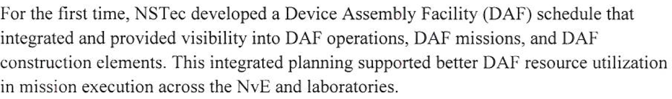
The Nevada Test Site’s Device Assembly Facility was built at the end of the Cold War to, as the name implies, assembly nuclear weapons devices for full-scale testing. It has sat largely unused since the beginning of the testing moratorium in 1992, but might play a significant role in NNSA’s so-called alternative plutonium strategy where it would act in part as a long-distance plutonium vault for the Los Alamos National Laboratory. “NvE” is likely a typo and should be NSE or Nuclear Security Enterprise, NNSA’s new euphemism for its nuclear weapons complex.

Page 25:
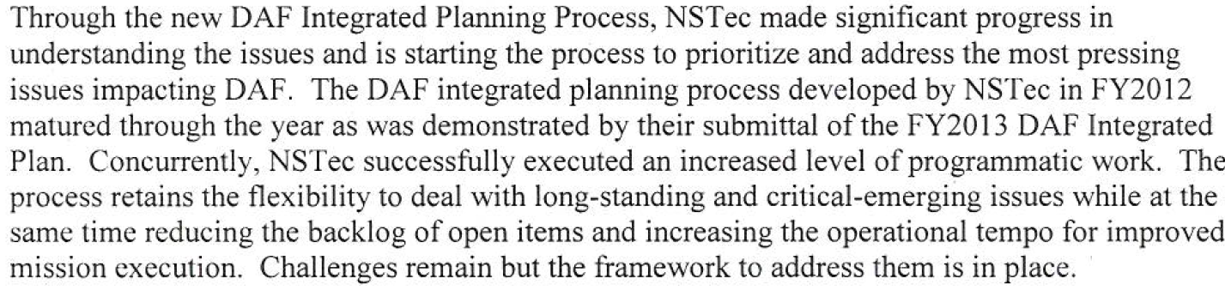

Page 27:
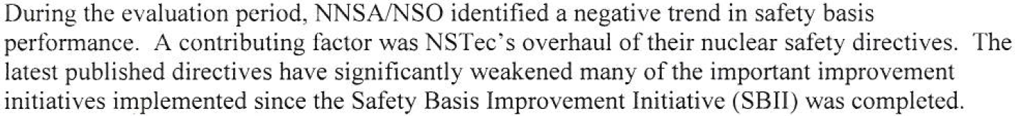

Page 28:
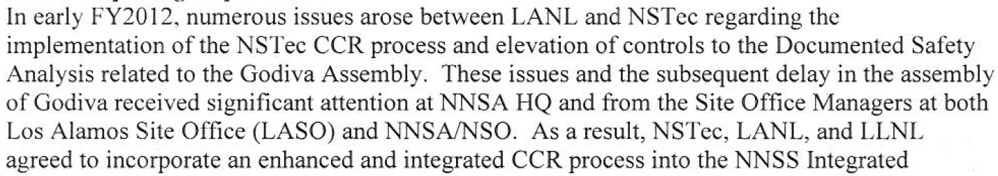
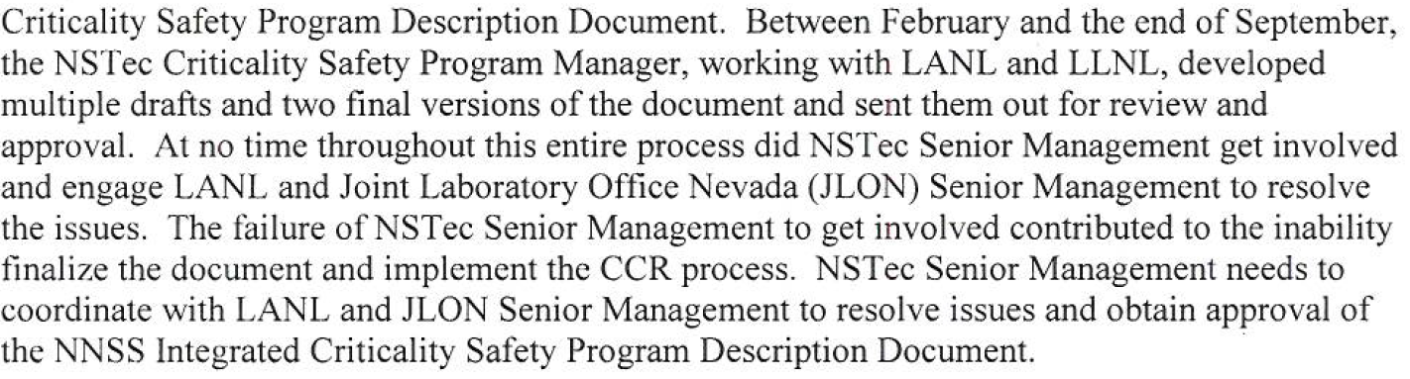

Page 32:
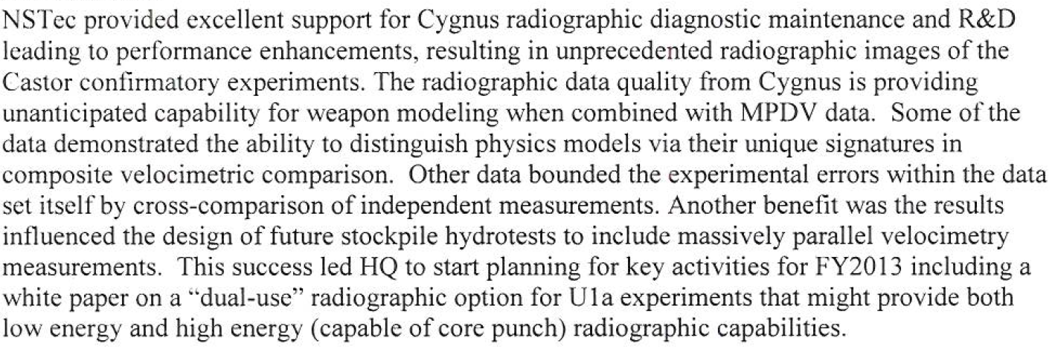

Page 33:
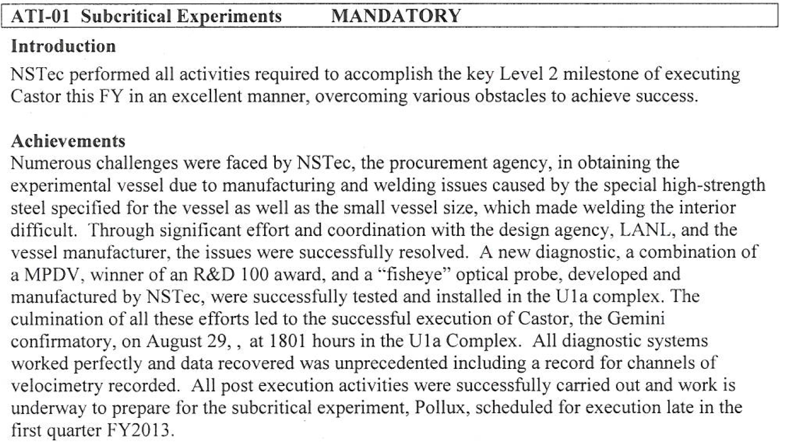

- End of FY 2012 NNSS Performance Evaluation Report Excerpts -
B&W Pantex
FY 2012 Performance Evaluation Report

Page 4: PO #P-1S: fiscal year 2012 “Getting the Job Done” List Done (Pantex Anchor)
B&W Pantex substantially exceed expectations with over 100% completion of all four performance targets; 113% in Limited Life Component deliveries, 107 % in weapon surveillance deliverables, 112% completion rate in scheduled dismantlements and 101% of W76 LEP deliverables. These goals were accomplished in spite of changing baseline workload levels, technical issues, and funding challenges.

Performance Assessment:
Performance Target #P-1.1: Complete all limited life component exchanges consistent with the annual assessment to keep operational deployment systems functional. B&W Pantex completed 113% in limited life component PCD deliveries as a result of the addition of four unscheduled kit deliveries.
Performance Target#P-1.2: Execute surveillance activities required to support annual assessment and certification.
B&W Pantex completed 170 surveillance units, 13 more than baseline schedule goal as a result of additional disassembly and inspections (D&I) in the B61, W78 and W80 programs.
Performance Target#P-1.3: Exceed planned dismantlements to include B53. B&W Pantex completed 112% of the dismantlement baseline schedule goal. The B-53 was completed early in the fiscal year, additional dismantlements for the W76 and W80 were completed and the entire stockpile of W80-0 was dismantled this FY.
Performance Target#P-1.4: Meet W76-1 deliveries to Navy.
B&W Pantex completed 101% of the W76-1 LEP baseline schedule goal. This was accomplished in spite of several technical issues including a Significant Finding Investigation late in the fiscal year which seriously threatened production deliveries. All scheduled LEP deliveries to the Navy were met.

Page 5: Performance Assessment:
Performance Target #P-2.1: Achieve FY12 Directed Stockpile Work (DSW) Directive
Schedule quantities (excluding work evaluated elsewhere in the PEP).
B&W Pantex completed 762 weapon deliverables, 61 more than the FY12 directive schedule baseline for a completion rate of 109%. This was accomplished in spite of numerous technical and funding challenges, equipment issues and late receipt of critical components for assembly operations. Additionally, B&W Pantex played a key role as the enterprise weapon production integrator.
Performance Target #P-2.2: Complete FY2012 DSW Level 2 Milestones as defined in the Milestone Reporting Tool (MRT) database. B&W Pantex completed all Level II milestones for the FY as identified in the Milestone Reporting Tool.
Performance Target #P-2.3: W76-0 Complete FY2012 PCD scheduled PCD W76-0
Dismantlement quantities.
B&W Pantex completed 104% of the schedule W76-0 dismantlements early in the fourth quarter baseline schedule deliveries. Timely coordination between B&W Pantex and the design agencies resulted in development of contingency processes, which successfully met these challenges.
Performance Target #P-2.4.a: B83: Complete the B83 Tooling Upgrade project milestones in accordance with the approved Project Execution Plan. The B83 SS-21 Tooling Upgrade was authorized in April. The recovery plan for FY12 surveillance, part of the project execution plan, was completed ahead of schedule.
Performance Target #P-2.4.b: B83: Complete B83 surveillance workload in accordance with the approved schedule. All B83 surveillance units were completed in July with delivery of the last Cycle 112 test bed to the Weapons Evaluation and Test Laboratory. D&I Quality Evaluation Tracking components were shipped by the end of September, in spite of Offsite Transportation issues. The B83 SS-21 Tooling Upgrade was authorized in April.
Performance Target #P-2.5: W84 Complete the KS project milestones in accordance with the approved project plan and schedule. B&W Pantex completed all milestones included in the approved Known State project plan and schedule. Unavailability of technical advisors to the Nuclear Explosive Safety Study Group forced the rebaselining of the original approved schedule. W84 KS is delayed out of Pantex control.

Page 8: Performance Target #P-6.1: Integrate the Y12 Canned Subassembly (CSA) schedule, the LANL Pit production schedule, the SRS reservoir schedule and KCP major component schedule with the Pantex Production schedule. Schedules for key inbound components received from B&W Y-12, LANL, the SRS, and the KCP have been developed by linking them to the internal Master Production Schedule. Pantex exceeded expectations by including SNM containers to and from Y-12. Furthermore, B&W Pantex hosts a monthly Production Agency VTC to facilitate cross-site communications; enabling the contractors to resolve issues before they impact deliverables.

Page 9: Performance Target #P-6.3: Collaborate with Y-12 through the Manufacturing Software Systems team to ensure an interface capability exists for sharing production information following the implementation of OSD&I and the Y-12 Momentum projects. In this joint target, B&W Pantex has exceeded expectations by working with NA-122 and B&W Y-12 to not only look at synergies between the two systems and projects and also to explore inclusion of all workload planning documents into the design phase of both systems. B&W Pantex has worked closely with all stakeholders and customers in designing and implementing OSD&I.

PO #P-7: Comprehensive Core Surveillance Program in support of nuclear weapons Certification
B&W substantially exceeded expectations by completing 170 surveillance units, 13 more than the baseline directive schedule. Additionally, B&W Pantex reported surveillance completions almost real time through the Quality Evaluation Requirements Tracking System (QERTS), and provided full support to the Surveillance Program Office.

Page 12: Performance Target #P-10.2: Develop a plan for extending the multiple HE pressing tool from “proof of concept” to implementation, and complete FY2012 milestones in the plan. B&W Pantex substantially exceeded expectations on this element by transitioning from “proof of concept” to full scale production in Dual Stack Pressing. This element will allow Pantex to exceed deliverables for the W-76 Life Extension Program (LEP). These high quality hemispheres will allow Pantex to exceed deliverables. All milestones are complete and Dual Stack Pressing has been conditionally accepted by the Design Agency for War Reserve parts.

Page 13: Performance Target #P-12.1: Enhanced Pit Storage - Develop and implement facility enhancements, including nuclear safety documentation, that support an increase in Pantex’s ability to store pits in additional nuclear material capable facilities. B&W Pantex met expectations regarding the management of the Nuclear Materials Program at Pantex. The M&O contractor continues to be vigilant in the staging/storage of pits at the site, including the management of available space for optimal pit storage, including the management of pit storage in Buildings 12-64 and Bldg. 12-116.
It’s believed that Pantex is bumping up against its plutonium pit storage limit 20,000 approved in a 1996 Site-Wide Environmental Impact Statement (SWEIS). Arguably a new SWEIS is needed.

Page 14: PO #P-13S: MOX Feedstock
B&W Pantex performance was good for this Performance Objective.
Performance Assessment:
Performance Target #P-13S.1: Provide pits to LANL per the document “Pit Campaign attachment to PMT-4-2007-154.”
B&W Pantex met expectations regarding this objective. The M&O contractor worked effectively to ensure that requested and scheduled pit shipments were accomplished in a timely manner. They worked well with their offsite customers in the accomplishment of these transportation efforts per the approved schedules. Schedule disruptions and missed schedules were thwarted due to the M&O contractor’s vigilance keeping their customers abreast of emerging anomalies.

PO #P-14S: Power Source Dismantlement Project (RTGs)
B&W Pantex performance was good for this Performance Objective.
Performance Assessment:
Performance Target #P-14S.1: Ship containers of power sources to LANL per the approved plan. B&W Pantex met expectations regarding this objective. The M&O contractor worked effectively to ensure that requested and scheduled RTG shipments were accomplished in a timely manner.
PO #P-15: Special Nuclear Materials (SNM) Operations
B&W Pantex performance was good for this Performance Objective.

Page 15: Performance Target #P-15.2: Production Performance - Complete FY2012 baseline scheduled deliverables.
B&W Pantex met expectations regarding the revised baseline deliverables for SNM Operations activities. The original baseline deliverable schedule was revised to reflect fewer deliverables in the areas of LGSS and Pit Requalification. Achieving the revised scheduled deliverables reflect a B&W Pantex SNM Operations commitment in the face of some sizeable equipment downtown sic challenges during this fiscal year. B&W Pantex was able to overcome these challenges and meet the deliverables schedule.

Page 18: Performance Target #P-18.1.c: Safety basis metrics and performance leading indicators extent to which Metrics and Performance Indicators are effectively managed to improve nuclear safety and quality.
This objective was not met. B&W did not communicate to NPO any demonstrated improvements to nuclear safety and quality as a result of metrics and performance indicators. At the end of the year, B&W did transmit “improvement initiatives,” which do not appear to correlate to the metrics provided and therefore do not demonstrate completion of this target because the initiatives are not a result of effective metric analysis. In fact, one initiative to “streamline the Process Hazards Analysis” which is a process used for high explosive safety, is unrelated to the metrics and not focused on nuclear safety.

Page 24: PO #P-25S (NEW): W80 Dismantlement – Exceed Baseline
B&W Pantex substantially exceeded expectations by completing 118% of the baseline W80 dismantlement schedule, three months ahead of the PCD requirement. All W80-0 weapons in the stockpile have been dismantled.

Page 30: Performance Target #O-4S.5: Publish FY12 Pantex Strategic Infrastructure Plan.
B&W Pantex substantially exceeded performance in all significant criteria areas in publishing the Pantex Strategic Infrastructure Plan one month ahead of schedule. Plan was published with minimal changes on August 29, 2012 and sent to HQ on September 17, 2012.

Page 33: Performance Target #O-7.3.a: Improve & enhance NPH mitigation (flood, seismic, lightning) support the mission extent that a prioritized risk based flood mitigation/prevention strategy implemented and associated Project Plan is developed.
This objective was met. The B&W Pantex Risk Based Flood Mitigation/Prevention Improvements Master Plan was submitted by 3/30/12. The plan appropriately prioritized the needed plant improvements necessary to mitigate/prevent flooding from a PC-1 storm/flood event.
Pantex experienced major flooding in July 2010.

Page 36: Performance Target #O-10.1: Transition from volunteer organization to designated position based upon job task analysis to the depth required to ensure an effective response.
B&W Pantex developed, approved, and implemented the Emergency Response Organization Transition Plan. The Plan allowed B&W to transition from a volunteer organization to designated position with a number of tasks to be completed at an unspecified future date. Generally, a number of significant tasks/actions in the Plan have not been completed including ERO as part of performance evaluation process. Pantex had a volunteer emergency response organization?!

Page 36: Performance Target #O-10.3: Develop a formalized process that will ensure the adequate staffing/deployment of emergency response facilities and functions.
B&W developed an ERO Watch Bill that allowed the transition from a volunteer to specific organizational division assigned positions. To enhance the emergency response program, B&W updated many of the Handbook(s) that incorporate checklists to better reflect the ERO role-based work-flows. Also, the ERO Watch Bill is described in a desk aid rather than a formal implementing procedure.
Good to know that “adequate staffing/deployment of emergency response facilities and functions” will be formalized!

- End of FY 2012 Pantex Performance Evaluation Report Excerpts -

NATIONAL NUCLEAR SECURITY ADMINISTRATION
FISCAL YEAR 2012 PERFORMANCE EVALUATION REPORT
OF SANDIA CORPORATIONFOR THE MANAGEMENT AND OPERATION OF SANDIA NATIONAL LABORATORIES
Contract No. DE-AC04-94AL85000

Page 1: Sandia’s self-assessment of its performance was submitted October 1, 2012 as the FY12 Sandia Performance Evaluation Assessment Report (PEAR). Although, Sandia’s assurance processes identified and addressed issues and challenges throughout the year, the majority of the PEAR lacked a self-critical analysis of the pertinent issues and challenges affecting mission accomplishment and Sandia management’s efforts to address these challenges. The impact of this omission raises concern by NNSA regarding Sandia’s self-criticism and that the NNSA PER had to address these issues to ensure a balanced, overall assessment of Sandia’s performance against documented expectations. In addition, Sandia management has not addressed long-standing, systemic issues in Assurance, Environment, Safety and Health (ES&H), and Quality. Though Sandia has undertaken numerous initiatives, significant improvement in these areas has not been demonstrated. Sandia’s ability and willingness to evaluate themselves, balancing accomplishments and challenges, and address systemic issues in a timely manner, becomes vitally important as we operate in the Strategic PEP environment.

Page 2: Although Sandia is maintaining effective programs in Operations, Sandia continues to have difficulty in several areas. Sandia continues to struggle with demonstrating a safety conscious work environment and line implementation of Work Planning and Control (WP&C) requirements as evidenced by both operational events and external assessments. Although Sandia recognizes these concerns and has initiated actions to address them, effective line implementation has not been achieved. Sandia needs to identify and understand the aggregate causes of the recent events (e.g., Halon cylinder, fume hood, etc.) in order to identify and address underlying safety concerns. With regard to IS&S, the Safeguards & Security Integrated Assessment Program has not resulted in measurable improvements in security-related assessments of line operations. Page 3:
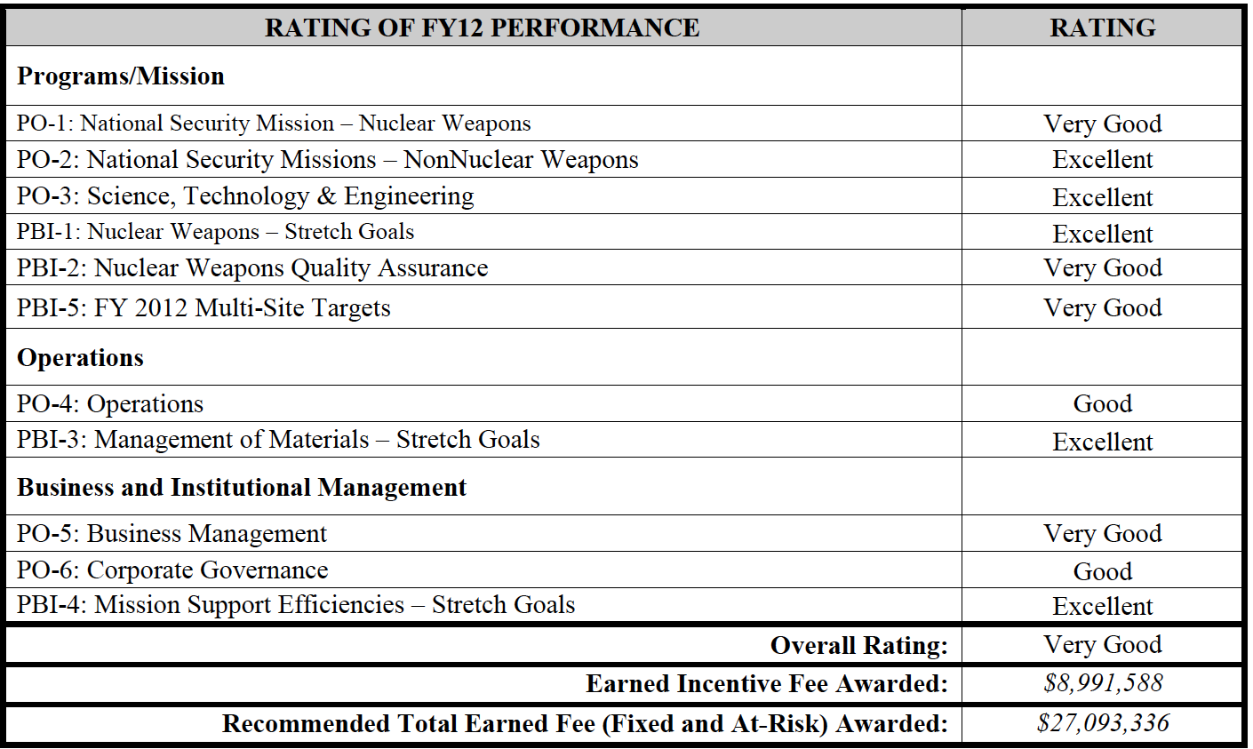

Page 5: Sandia provided innovative cost saving design trade-offs to meet the submittal of theB61-12 Weapons Development and Cost Report (WDCR) refined cost estimate realizing significant cost reduction over the life-of-program relative to earlier estimates. The W76-1 LEP production continued to be at risk through FY12. Deliveries to the DoD were not affected due to renegotiated schedules and requirements with the DoD and Atomic Weapons Establishment. Sandia has not fully embraced their Production Agency role and has not utilized staff from Lockheed-Martin or other NNSA sites with production experience to support their mission, which has affected Sandia’s ability to fully partner with the Kansas City Plant (KCP) in their Production Agency mission. Sandia missed eight of their 44 Level II Milestones with several being green throughout the year and projected to be blue until the last quarter when they went red, a further indictment of the Sandia Management Assurance System and self-assessment process. Sandia showed improvement in response to obstacles for each Weapons Reliability Report release. Sandia assisted the Weapon Dismantlement and Disposition program to remove the last legacy trainer with unique hazards. In response to the NNSA/NA-10 Program Review, Sandia completed Integrated Weapons Evaluation Team-like Surveillance Implementations Plans and provided Need-To-Know verification for distribution of the Significant Finding Investigation (SFI) database and procedural guidelines for document control. There were initial concerns with the program management staff in new positions during critical out year budget planning but this appears to be on track for FY13. The W87 System Testbed qualification was not met due primarily to ambiguity in the Sandia design drawing, which resulted in the testbed cable being manufactured to a configuration unusable by Sandia. Due to this, the drawings must be revised and a new date for qualification will be established.

Page 5: The importance of materials property data obtained from Z Machine experiments to understanding weapons physics was recognized by the External Review Panel. The data from Z Machine resulted in new weapon design code models to be developed for several metals and gases. NNSA was especially pleased with the Equation of State experiments for noble gases conducted at the Z Machine as well as the data obtained from the Pu experiments and referred to the data as “spectacular”. Completed the development and testing of an improved Z Machine containment for FY13 Pu experiments at higher currents/pressures, which is of high programmatic value for NNSA, and also collaborated with the Los Alamos National Laboratory (LANL) to evaluate potential approaches for conducting molten Pu experiments in FY17. Z Machine significantly increased the shot rate from 118 in FY11 to 161 in FY12, and adjusted seamlessly to schedule changes outside their control (e.g. Pu shot schedule change). Additionally, several new experimental platforms/capabilities (e.g. dual Marx trigger, gas puff) and diagnostics were fielded on Z Machine. Made advancements in the linear transformer driver (LTD) technology, doubling the power output generated by a single LTD cavity, which reduces the size and cost of future LTD-based accelerators by a factor of two. LTD Architecture is the basis for a next-generation pulsed power accelerator, which was documented in the Short-Pulse Accelerator and Reactor Center proposal submitted to NNSA. Z Machine’s successes are in marked contrast to the failure of the National Ignition Facility at the Lawrence Livermore National Laboratory (see LLNL PER excerpts).

Page 6:
Significant Accomplishments
• Computing improvements and new program integration strategies resulted in enhanced B61-12 LEP simulation support including early integration of simulation into the design process, supporting the radar nose impact, Lightning Arrest Connector (LAC) capability, spin rocket motors, and glass-to-metal seals. Supported the B61-12 LEP with numerous design trades-offs analyses and detailed design studies, as well as simulation support of environmental specification determinations for components and sub-assemblies…
• Through the past 20 years, Sandia has been required to perform at least one major acquisition (e.g. W76-1 LEP) and several ALTs. During FY12, Sandia supported the B61-12 LEP and W88 ALT through Phase 6.3, the W78-1/W88-1 LEP through Phase 6.1, the W87/W88 common fuze, and multiple NG and Gas Transfer System ALTs for the W80, B83, W87, and B61-11. This is an unprecedented amount of activity to be balanced especially in light of the large number of retirements with experience that occurred during Calendar Year 2011.
• Supported nuclear design teams in the development of advanced technology and system concepts in the W78-1/W88-1 LEP 120 day cost study.
• Baselined 22 unique Microsystems and Engineering Sciences Applications components for the B61-12 LEP and W88 ALT, including three application-specific integrated circuits (ASICs) for the B61-12, four ASICs shared between the B61-12 and W88 ALT, and four ASICs unique to the W88 ALT.
• Fabricated and tested Complementary Metal-Oxide Semiconductor (CMOS7) compatible radiation hardened memory elements and improved ASIC wafer and die yield in the Silicon Fab from 15% to 50%. • Through the RTBF Program Readiness NCSP, provided support on an independent review team for the National Criticality Experiments Research Center at the Nevada National Security Site (NNSS) that identified the problem and led to the facility being able to regain fully operational status. Successfully completed a joint RTBF and SC milestone for the refurbishment of the dual-axis Cygnus radiographic system in support of the scaling and surrogacy initiative Gemini experiments. The effort resulted in Sandia delivering “exquisite radiographs” for the Castor confirmatory shot. Sandia also developed several options for low cost NNSS radiography for NNSA…
• Physically experimentally produced x-rays in spectrums previously unattainable outside of underground tests. Additionally, completed the largest yet experimental series at Z Machine dedicated to understanding the physics of blow-off impulse testing requirements...
• Completed the disposal of the Be contaminated items from the 2004 incident that occurred in Building 809 under budget, disposing of 8,367 lbs of Be contaminated and 6,328 lbs of contaminated material. • • • • Exceeded expectations during the unplanned mission for Operation Harpoon Crab; worked with a NNSA and DoD team to successfully execute and complete the mission, which was a high priority for NNSA.

Page 7
Opportunity for Improvement
• Did not deliver on the W87 Small Ferroelectric NG (SFENG) FPU in 2012 due to multiple technical issues (External High Voltage Breakdown [eHVB] and Internal High Voltage Breakdown [iHVB]) resulting in a Code Blue. The impact is a possible delay in the FPU. In addition, there are now possible delays in other programs. Sandia lacks the technical experience to resolve multiple, significant issues concurrently as was demonstrated when trying to resolve both the Loss of Bias and eHVB concurrently. Had more red milestones than in previous years with several of the milestones being green throughout the year with a projection of blue at the end of the year only to end with a red status. Because of this, NNSA is concerned about Sandia’s ability to demonstrate program management at a higher level.
• Did not complete the ACF CPD B61-11 test after two years of effort. When the Sled Track Facility (STF) was shut down after the accident in 2009, Sandia decided to start up the STF before the ACF without consulting the NNSA about the mission need for the ACF to be restarted. As a consequence, Sandia lost much of their expertise during the restart of the STF and Sandia has had to reconstitute a new team the last two years with almost no expertise from previous ACF CPD tests. Sandia should consult with NNSA on decisions that could affect mission needs.
• The progress made on the Weapons Evaluation and Test Laboratory (WETL) tester did not meet schedule. The tester upgrade completion schedule was ambitious and success oriented, but it was based on the knowledge gained in the recent past by those at Sandia who manage this work. NNSA will work with Sandia to re-establish a new plan and schedule that are challenging, but achievable and allow for time to address unforeseen issues that commonly occur during development. Sandia did not complete testing for six B61-7/11 testbeds at WETL due to this delay. The upgrade schedule was known, as well as the questionable condition of the old tester. A decision was made to wait on testing until the new schedule was available to give Sandia maximum opportunity to meet the schedule; maintaining the old schedule would have required the same resources. Successful project management continues to be a struggle for the WETL tester upgrade project. On significant decisions, Sandia needs to continue to obtain NNSA concurrence in advance of the possible impacts.
• Although the number of 10 CFR 824 type incidents has decreased from FY11 to FY12, SSO remains concerned with the number of cyber security incidents. Many of these incidents involved program specific activities as highlighted in a Sandia letter dated July 23, 2012. In addition to the impact of computer unavailability when incidents occur, this trend increases the risk of impacting work if a security breach or external investigation were to occur. This needs to be mitigated to reduce the risk of an impact to mission work.

Page 14: Sandia self-discovered a non-compliance issue with their internal wastewater permitting process (an inappropriate discharge to the sanitary sewer) and NNSA is concerned about the extent of similar conditions in the program. In addition, the New Mexico Environment Department performed a Safe Drinking Water Act inspection in June and indicated a potential violation. The significance of the potential violation has yet to be determined as it is now associated with the Kirtland Air Force Base underground fuel leak and has been elevated to the Environmental Protection Agency (EPA).

Page 16: Again this year, Sandia management did not provide the economic analysis requested by NNSA/NA-16 for the Mission Support Complex. The project had been proposed by Sandia as a high priority line item in fall 2010. At that time, NNSA directed Sandia to bring forward the economic analysis to support approval of an NNSA Critical Decision 0 for alternative financing of this project and Sandia never completed this. This issue was also not addressed in the PEAR. After the Kansas City Plant slipped under the radar Nuclear Watch New Mexico was assured by congressional staff that there will be no more major NNNSA projects built by “alternative financing” provided by the private sector. We will be keeping an eye on this.

Page 23: Summary of Performance
ASC/ICF/SC goals - Sandia continues to push themselves to achieve impactful FY12 accomplishments in the ASC, ICF and SC campaigns such as excellent integration and design support between the Sandia modeling and component design efforts, development of containment for higher current Pu test shots, innovative new target designs, and refinement of computational simulation capabilities.
RTBF goal – Sandia met or exceeded expectations for the three RTBF stretch goals. Sandia delivered a list of programmatic equipment in RTBF funded mission critical facilities vital to sustaining capabilities. This list was completed on time and further refined over the last two quarters. Sandia also applied funding to support the Tonopah Test Range (TTR) revitalization and Silicon Fabrication Recapitalization (SSiFR), which exceeded expectations.
W88 ALT goal – Sandia submitted input to the WDCR in June for the three-point estimate that was beneficial and necessary to perform the Monte Carlo simulation to assist in arriving at a high confidence program cost estimate. In addition, Sandia generated a comprehensive basis of estimate that supported their WDCR estimate.
Kansas City Responsive Infrastructure Manufacturing Sourcing (KCRIMS) – Sandia’s weapon systems programs utilized existing FY12 funding allocations to support Sandia’s planning, response to materials dispositioning, and high priority requalification activities. Sandia responded to all KCP disposition calls, including a review of surplus items in KCP stores. Sandia identified 70 defined KCRIMS related risks and increased communications and support in the partnership with KCP counterparts to assure a successful move execution. Sandia provided requalification plans and released a review of the Transportation Study for transportation environments for the move to the new facility.
B61 Goal – Sandia provided innovative cost saving design trade-offs to meet the submittal of the B61-12 WDCR refined cost estimate realizing significant cost reductions over the life–of–program relative to earlier estimates. Sandia’s transparency into the cost development allowed NNSA to understand the trade-offs and decisions made in the development of the WDCR. No mention is made of the fact that the estimated cost of the B61 Life Extension Program has exploded from ~$4 billion to ~$10 billion or more, casting the whole program in doubt. NNSA seems to blame the Kansas City Plant (see its Performance Evaluation Report) and let Sandia off the hook.

Page 23:
Significant Accomplishments
• ASC Modeling & Simulation provided excellent integration and design support for the B61-12 LEP Program. Significant engineering analysis results were delivered including numerous analyses supporting design tradeoffs, simulations supporting the environmental specification determination for components and sub-assemblies, and determination of worst-case accident scenarios for system test design. Additionally, Sandia made great strides in simulation credibility and Verification and Validation (V&V) as reflected by their revised V&V plans and Predictive Capability Maturity Model assessments conducted of their models and capabilities.
• ICF demonstrated an established Pu dynamic materials shot as routine work on the Z Machine by conducting three Pu shots in FY12, including both ramp compression and flyer plate experiments. The fourth Pu shot was deferred into the first week of October 2012 due to delays associated with the sample preparation at LANL; however, Sandia and LANL collaborated very well on this effort throughout the year. Additionally, Sandia completed the development and testing to demonstrate the capability of the next-generation containment system at16 mega-amperes, despite the increased work and testing that were required due to the explosive Ultrafast Closure Valve (UCV) not meeting the leak rate specification during higher current containment testing. The UCV evaluation effort included development of additional capabilities to perform ultrasound imaging, x-ray radiography, and material analyses of each UCV, which resulted in a more thorough investigation of the underlying issues with the legacy UCV. In addition, new tools for the R&D efforts of the program were created. Sandia completed a comprehensive evaluation of higher pressure Pu experimental conditions needed to address critical long-term SC needs, including both pulsed power and other NSE facilities which could meet the desired conditions. The documentation included experimental plans to reduce risks and demonstrate feasibility of diagnostics, drivers, targets, and containment, and was presented to NNSA.
• Applied $6.4M funding above the $4M target to the SSiFR facility per the risk ranked study. The funds provided upgrades to the uninterrupted power system and the clean room controls, design of the replacement solvent fans and ducting, removal of obsolete equipment and room prep in anticipation of FY13 recapitalization funds, and the replacement of two CMOS7 Diffusion Furnaces with the associated engineering design and construction required for installation. This succeeded in replacing some of highest risk equipment in the facility early in the recapitalization project.
• Applied $4M funding above the $2M target to TTR revitalization needs in accordance with the revitalization study. The funds provided Depot Level Maintenance for two tracking radars, replacement of a mobile telemetry system to allow for future B61-12 LEP testing, and a backup generator system for critical test infrastructure as well as smaller improvements. Additionally Sandia funded and completed a Master Plan Study to evaluate Green Field versus Brown Field options.
• Allocated FY11 carryover funds to support FY12 project team program management efforts. Sandia released 42 KCRIMS related Qualification Plans in FY12. Of these 42 releases, 18 met Sandia’s FY12 planned commitment. The remaining 24 released qualification plans exceeded expectations as they were early FY13 releases. These qualification plans were released without affecting core weapon system activities.
• Performed exceptional work on the W88 ALT 370 in FY12.

Page 27:
• Exceeded expectations by removing eight HC3 or remote-handled, non-MOX NDU items, and a number of other legacy nuclear material containers, which represents substantial progress toward reducing the need for the Manzano Nuclear Facilities, one of Sandia’s HC3 nuclear facilities.
• Removed radioactive materials from Building 927 at the SNL/CA site, further reducing the radioactive material liability, reducing security costs, and clearing the way for open campus enhancements to the site. Through careful inventory analysis and aggressive disposal activities, Sandia substantially reduced the number of containers of chemicals that have been on site over ten years by over five times the target goal.
• Despite numerous challenges, successfully completed the removal of the final inventory of non-certified Cobalt-60 source pins from the Gamma Irradiation Facility (GIF). During the follow-on efforts to change GIF operating processes, Sandia coordinated emergent, mission-related work regarding the replacement of aging Cobalt-60 sources in, and refurbishment of, a Gamma Cell device. Sandia has planned to perform the work at the GIF utilizing the shielded cells, transportation infrastructure, and facility expertise.

Page 31:
PBI-5: FY12 Multi-Site Targets
Achieve multi-site goals as approved by the Deputy Administrator for Defense Programs to demonstrate Sandia Corporation’s (Sandia) collaboration and leadership within the Nuclear Security Enterprise. Demonstrate successful performance against Multi-Site Targets as documented in NNSA’s Milestone Reporting Tool (MRT). Adjectival Rating: Very Good
Summary of Performance
Surveillance – Sandia continued improvements for throughput at the WETL including increasing test complexity for all systems and meeting lab test requirements, consistent with funding. As of September 30, 2012, Sandia executed 25 stockpile flight tests and 53 stockpile laboratory tests under the Core Surveillance Program. Sandia established planning tools for Component and Material Evaluation (CME) for work scope definition, prioritization, and resources to facilitate integration with KCP. Sandia established a formal transition process for CME to Core Surveillance and validated the guidelines across LACs and the MC4217 detonator. Sandia conducted ~1140 subsequent tests at the WETL on firesets, radars, inertial switches, stronglinks and command disable components across each legacy weapon system. Sandia also fully supported ongoing Joint Test Assembly (JTA) development work for the B61 and B83 and completed Quantification of Margins and Uncertainties analysis on numerous components. Sandia is commended for leveraging work for the B61, B83, and B61 LEP JTA development resulting in significant cost savings and streamlined schedules and excellent support through a detailee in Washington, DC.
W76-1 - Issues with the MC4682 capacitor withheld Lots 5 and 6 from production during FY11, creating a critical demand schedule for FY12 lots. Sandia implemented schedules to minimize the impact to KCP. Both the Navy and NNSA agreed to the reduced schedules and weekly video teleconferences monitored progress and issues. Lot 7 and 8 were late one month and one week and Lot 7 was short by 30 of 90 capacitors resulting in KCP adjusting work to a compressed schedule. Lot 9 was on time with 9 extra capacitors. An unsatisfactory quality audit finding was documented against the MC4682 capacitor vendor due to configuration management. Vendor qualification, oversight, and management for capacitor production remain concerns. Qualification of the second vendor for the production of the MC4682 capacitor remains a concern as well. All FY12 Arming, Firing & Fuzing (AF&F) shipments met the NNSA reduced negotiated schedule.
B61 LEP – Sandia completed the Option 3B design allowing the completion of the WDCR by all sites within schedule. Sandia develop an Integrated Master Schedule (IMS) to meet the deadline of the WDCR and developed the technology maturation roadmaps for the Option 3B design.
W78-1 LEP – Sandia efficiently executed their portion of the W78/88-1 LEP Phase 6.1 study with Lawrence Livermore National Laboratory (LLNL), NNSA, and the Air Force. Beginning in June when Nuclear Weapons Complex approval was granted, Sandia sustained their momentum by transitioning to the Phase 6.2. Additionally, Sandia successfully completed work outside of the Level II Milestones by completing the 120 day study. This challenging task added scope and complexity to the results derived from Phase 6.1. Sandia worked simultaneously with LANL and LLNL to develop solutions, illustrated in two full scale rapid prototype models from each of the design teams, documented the work in reports and provided countless briefings to senior NNSA, DoD and Congressional staff.
National Ignition Facility (NIF) – Though ignition was not achieved at the NIF, NNSA was pleased with Sandia’s support for the National Ignition Campaign (NIC) effort. Sandia participated broadly in the design, fielding, and post-shot analysis of NIC indirect-drive tuning experiments in the areas of convergent-ablator physics, shock timing, and neutron physics. Additionally, Sandia’s designed x-ray burn history diagnostic, the Streaked Polar instrumentation for Diagnosing Energetic Radiation (SPIDER), was fielded at NIF and obtained data during FY12.

Page 32: U1a - Sandia’s refurbishment of the Cygnus accelerators and commission for radiography in support of the Gemini subcritical experiments. Sandia contributed to the successful execution of CASTOR subcritical experiment at the U1a Complex at the NNSS on August 29, 2012.

Page 32: Opportunity for Improvement
• The W76-1 LEP continued to be at risk through FY12. NNSA remains concerned about the start-up of the second supplier which slipped from June 2013 to October 2013. As a consequence, capacitors will continue to be limited throughout FY13 and there is risk should any new problem occur in FY13. Although the Code Blue for Launch Accelerometers was closed in FY12, recent failures in July have implications that could impact shipments of AF&Fs in FY13. Deliveries were not affected due to renegotiated schedules and requirements. Sandia has not utilized resources of Lockheed- Martin staff or other NNSA sites with production experience to support their mission. This has affected Sandia’s ability to fully partner with KCP in their production mission.
• The B61 LEP – While Sandia has developed an IMS for the program, it cannot be effectively utilized by the complex to identify schedule concerns. There is concern over the ability to properly role up PRT tasks and support critical path assessments. The IMS must be refined during Phase 6.3 to improve the overall usefulness of the system by the Federal Program Manager and to improved capabilities for schedule risk assessment. Continue to work with NNSA to improve the stability of the IMS and usability over the life of the program.

- End of FY 2012 Sandia Performance Evaluation Report Excerpts -

Savannah River Site Performance Evaluation Report
Not Yet Available, Under Request

Performance Evaluation Report for Babcock and Wilcox Y-12 Technical Services, LLC Contract Number DE-AC05-00OR22800 Evaluation Period: October 1, 2011 through September 30, 2012

Page 3: II. Operations
The security event of July 28, 2012 was a major failure under the Operations performance objective. Unacceptable performance occurred across all aspects required for successful operations such as training and qualification, readiness/response, procedures and processes, maintenance, testing, and situational awareness. Based on that security event and the contributing causes none of the available fee would be earned under the Operations performance objective.

Page 3: The overall rating for Engineering and Nuclear Safety (ENS) for FY 2012 is “Good”. The basis for the rating is due to deterioration of performance during FY 2012 and that performance metrics do not drive improvements in processes and identify implementation issues. The safety basis program continued to suffer from quality of safety basis document submittals that resulted in potential inadequacies in the safety analysis, implementation problems, and lengthy periods to resolve NPO comments and resubmit documents, particularly the 9204-2E annual up date and UPF preliminary safety design report (PSDR).

Page 6: Project Management –Major Line Items, Uranium Processing Facility (UPF) The overall rating for Major Line Items, UPF, is “Unsatisfactory.” This rating is based on the facility size (fit) issue that will increase project cost, extend the project schedule, and result in reduced project scope. Wit h over 75% engineering design reported as being complete, UPF project management notified NNSA that the UPF design team had reached the conclusion that the UPF process equipment and supporting utilities could not physically fit in the facility and maintain adequate operations and maintenance spaces, nor was there sufficient space margin to allow for design evolution and field changes. Notification t o NNSA did not occur until late April after the UPF CD-1 Reaffirmation ESAAB. The design resolution to this was not finalized prior to the end of the fiscal year, but was known that it would require a significant increase in design cost, extension of the project schedule, and required removal of planned processing capability from the project scope. The engineering replan delivered on October 19, reported a TPC cost impact of $539M and 13 month impact to the overall project schedule as a result of the Space/Fit issue, effectively using 45% of the NNSA contingency established during CD-1 Reaffirmation in April. The materialization of this risk, given the significance of the consequences at a reported 75% design completion juncture, leads to a conclusion that although identified as a project risk in 2009, aggressive management actions were not taken to manage or mitigate the risk. The project did not have a design margin management program or process to mitigate this risk. In addition, the formal communication and reporting of the fit issue w as not clear or forthcoming.

Page 7: reported a TPC cost impact of $539M and 13 month impact to the overall project schedule as a result of the Space/Fit issue, effectively using 45% of the NNSA contingency established during CD-1 Reaffirmation in April. The materialization of this risk, given the significance of the consequences at a reported 75% design completion juncture, leads to a conclusion that although identified as a project risk in 2009, aggressive management actions were not taken to manage or mitigate the risk. The project did not have a design margin management program or process to mitigate this risk. In addition, the formal communication and reporting of the fit issue w as not clear or forthcoming. The project has not been able to meet key project milestones and has been late in identifying that project schedule milestones would not be achieved. Significant examples include:
1) The 90% design maturity milestone by September was not met even though the project consistently reported through June that it was achievable even with the implementation of the UPF CD-1 Reaffirmation scope (as described in the 30 day plan). This misrepresentation was identified during the UPF Technical Independent Project Review;
2) The engineering replanning base line change proposal (BCP) to resolve the fit issue was due on August 31, and was reported to NNSA as not achievable on August 30. The engineering replanning BCP was delivered to NNSA on October 19;
3) The Preliminary Safety Design Report (PSDR) Revision 1 was scheduled to be completed on August 22, 2012. The project did not complete the PSDR on schedule and subsequently delivered to NNSA on September 25; and
4) The implementation of the 30 day plan changes did not occur during FY 2012 although direction was provided in March to implement the changes from the change in project scope. The project did not have a fully integrated project schedule for the ongoing design efforts at the beginning of the fiscal year. The integration of the design and the safety basis deliverables in the UPF project schedule did not occur until March. While working the resolution of the fit issues, the project design schedule did not reflect the ongoing work until a BCP for engineering design efforts was completed in September. The engineering replanning delivered on October 19, reported a TPC cost impact of $539M and 13 month impact to the overall project schedule as a result of the Space/Fit issue. In addition to the previously mentioned concerns, improvements are necessary in the area of monthly project reports and reviews; timeliness in the processing of BCPs following approval of trends; effective resolution of design quality issues; resolution of design issues and needed engineering process change s; timely and effective communication of project issues; proactive management of project risks, and resolution of safety analysis issues.

Page 7: Safeguards and Security Program Management
The overall rating for Safeguards and Security Program Management is “Unsatisfactory”. This rating is based on the complete failure of the security system/protective force response to the PIDAS penetration on July 28 and the completely unacceptable implementation and operation of the Argus security system. As implemented, Argus unreliability significantly contributed to the PIDA S penetration event of July 28. B&W’s response to t he initial security incident on July 28 was also unsatisfactory. Significant federal leadership was required in the absence of contractor leadership and support that was “...slow, disoriented, and requiring intervention by NPO.” Another negative contributor to the eventual system failure, were the decisions put in place by the contractor Cognizant Security Authority (CSA) to loosen security requirements established by DOE order and/or the NNSA NAPs. Security system testing requirements were changed by the CSA process, which contributed to the unavailability of critical system needed to assess the security event. NPO assessments conducted prior to the security e vent identified a number of issues associated with the contractor’s CSA process and the lack of a critical self-assessment/corrective action program that were contributors to this event.

Page 8: Physical Security
The overall rating for Physical Security is “Unsatisfactory”. This rating is based on the complete failure of the security system/protective force response to the PI DAS penetration on July 28 and the completely unacceptable implementation and operation of the Argus security system. The transition of Y-12 alarm system to the NA-70 approved Argus standard by the Security Improvement Project (SIP) was started during this period. Argus related issues led to greater reliance on compensatory measures. It has proven extremely burdensome to the CAS /SAS operators, as installed, and has created significant hindrance to Operations. It has required very significant rework of the originally installed Argus System. The number of corrective maintenance work requests increased due to the SIP, Argus transition activities, and aging security systems. The increased work with limited availability of technicians resulted in increased time for equipment to be brought back into service and extended duration of applicable compensatory measures (i.e. the PIDAS camera out associated with the July 28th event). False and Nuisance Alarm Rate (FAR/NAR) data was not initially retrievable from the Argus system as implemented and NPO noted this in previous reviews and contractor feedback—August was the first time this information was readily available.

Page 13: Contractor Assurance
The overall rating for Contractor Assurance is “Unsatisfactory”. The contractor assurance system (CAS) was not utilized in a manner to help identify and remedy the degrading performance of systems critical to properly executing the mission of the Y-12 National Security Complex. The contractor focused on identifying, tracking a d resolving individual issues to the detriment of systems analysis and determining the effectiveness of those systems. The contractor maintained an extensive array of metrics (over 400) but failed to identify or otherwise designate which (if any) were key to understanding the performance of critical systems. The analysis process for metrics often stopped at the product of the logic with no interpretation of the information regarding significance or meaning beyond the result of the number crunching. Assessment activities under the CAS concentrated on compliance and status of issues rather than performance for executing the mission safely and securely. The contractor did not avail themselves of opportunities to learn from “information rich events” unless prompted by the Federal staff as part of oversight e.g., the lock out/tag out causal factors analysis. Overall the contractor was weak in being self-critical, an essential element of effective contractor assurance. Inadequacies of the CAS were a significant contributor to the security event of July 28, 2012 with respect to the degradation of critical security systems.

Page 23: ESSENTIAL PERFORMANCE BASED INCENTIVES
Redacted numbers marked by xxxx in the original.
I. Program A. W76-1 LEP Production
1. Complete xxx each WR Boat assembly units on at leas t a 90-day lead to the PCD in effect on October 1, 2011 (2011-A-PUB, dated 07/06/11)
2. Complete one each Shelf Life canned subassembly
3. Complete recertification of xxx sets of WR case parts on at least a 90-day lead to the PCD, in effect on October 1, 2011 (2011-A-PUB, dated 07/06/11) All activities successfully completed.
B. Dismantlement and Disposition
1. Complete the dismantlement of xxx B61 units – Completed.
2. Complete the dismantlement of xxx B53 units - Completed 109% of baseline.
3. Complete the dismantlement of xxx B83 units – Completed.
4. Complete the disposition of 8000 ft3 of weapon components off-site - Completed 107% of baseline.
5. Complete rapid tear-down on (2) W84 units – Completed.
6. Complete the dismantlement of xx B53 pits – Completed.
7. Complete the dismantlement of xx stretch W69 units – Completed.
C. Stockpile Systems B61 JTA Fwd Caps W76-1 JTA-2 W78 JTA-6 WW88 JTA-1,2,3,4 Specified quality evaluation activities All activities successfully completed.

Page 25: A series of performance-based incentives were established for maturing the design and completing specific design deliverables – either issuing them as “for u se as final design” or issuing them “for construction.” B&W met the delivery date for all design-completion based milestones with exception of completing 90- percent of the overall design by September 2012. T he individual design packages were generally evaluated to be quality deliverables. That said, the design-completion based deliverables represent, by B&W’s own analysis, an average of over 60-percent breakage. Each of their requests for “earning fee” on these design-completion based deliverables were denied, given the significant structural and interstitial equipment reconfigurations required to accommodate our essential processing capabilities.

Page 27: STRETCH PERFORMANCE BASED INCENTIVES
II. Operations
The Gateway was not met for this category.

- End of FY 2012 Y-12 Performance Evaluation Report Excerpts -

The eight NNSA nuclear weapons sites are the Los Alamos National Laboratory in northern New Mexico: the Sandia National Laboratories in NM and CA; the Lawrence Livermore National Laboratory in CA; the Nevada National Security Site (formerly the Nevada Test Site); and the four production plants: the Kansas City Plant for nonnuclear components; the Savannah River Site near Aiken, SC for the radioactive gas tritium used to “boost” nuclear weapons; the Y-12 Plant near Oak Ridge, TN, for nuclear weapons secondaries (which put the “H” in H-bomb); and the Pantex Plant for final nuclear weapons assembly near Amarillo, TX.

